**Project Documentation: Tours and Traveling Website**

**Table of Contents :**

1. Introduction
2. Project Overview
3. Features
4. Technologies Used
5. Usage
6. Feasibility Study
7. DFD(Data Flow Diagram)
8. ERD(Entity Relationship Diagram)
9. Images

10. Conclusion

**1. Introduction:**

The Tours and Traveling website is a comprehensive online platform designed to meet the needs of travelers looking to seamlessly book their next adventure. In today's fast-paced world where travel has become an integral part of our lifestyle, this website serves as a one-stop shop for individuals and families alike to discover, plan and book their dream vacation.

With an intuitive user interface and robust functionalities, the Tours and Traveling website aims to revolutionize the way people explore and embark on their journeys. Whether it's an exciting adventure in the mountains, a tranquil beach getaway or a culturally enriching city tour, our platform offers a wide range of travel packages to suit every traveler's preference and budget.

At the heart of our website is a commitment to providing users with a hassle-free and personalized booking experience. By seamlessly integrating user authentication features, including login and sign-in functions, we ensure that every user can securely access their account and conveniently manage their bookings and preferences.

**2. Project Overview :**

The Tours and Traveling website is a dynamic online platform designed to simplify and improve the process of planning, booking and managing travel for individuals, families and groups. In today's increasingly connected world, where travel has become more accessible and important than ever before, our website serves as a trusted companion for travelers seeking unforgettable adventures and seamless booking experiences.

2.1 Purpose:

The main purpose of the Tours and Traveling website is to create a one-stop shop for travelers to explore a variety of travel packages, destinations and activities, ultimately allowing them to create personalized and memorable travel experiences. Using cutting-edge technology and user-centric design principles, our platform aims to optimize the entire travel journey, from initial inspiration to post-trip reflection.

2.2 Target Audience:

**1 .Leisure Travelers:** Individuals and families seeking relaxation, adventure, and cultural immersion during their vacations.

**2 .Business Travelers:** Professionals in need of convenient and efficient booking solutions for corporate travel arrangements.

**3 . Adventure Enthusiasts:** Thrill-seekers and outdoor enthusiasts craving adrenaline-pumping experiences in exotic locales.

**4 . Solo Explorers:** Independent travelers looking for solo-friendly itineraries, group tours, and social networking opportunities.

**5 . Special Interest Groups:** Niche communities such as eco-tourists, foodies, history buffs, and wellness seekers with specific travel preferences and interests.

2.3 Key Functionalities:

**1 . Tour Listings:** Comprehensive database of tour packages, including destination highlights, itineraries, pricing, and availability.

**2 . User Authentication:** Secure login and sign-up functionalities to access personalized features, manage bookings, and view past travel history.

**3 . Booking System:** Intuitive booking interface with real-time availability checks, flexible date selection, and secure payment processing.

**4 . User Profiles:** Customizable user profiles with options to save preferences, review past bookings, and receive personalized recommendations.

**4 . Admin Dashboard:** Administrative interface for managing tour listings, user accounts, bookings, payments, and other site content (optional).

**3. Features :**

3.1 User Authentication:

**1 .Login:** Users can securely log in to their accounts using their email address and password.

**2 . Sign-Up:** New users can create accounts by providing basic information such as name, email, and password.

3.2 Tour Listings:

**1** . Browse Tours: Users can explore a diverse range of tour packages categorized by destination, theme, duration, and price.

**2.** **View Details:**  Each tour listing includes detailed information such as itinerary highlights, inclusions, exclusions, pricing, and availability.

3. Interactive Maps: Visual representations of tour destinations and attractions provide users with a comprehensive overview of the travel experience.

3.3 Booking System :

**1. Book Tours:** Users can seamlessly book tours directly through the website by selecting desired dates, specifying the number of participants, and providing relevant contact and payment information.

**2.** **Flexible Booking Options:** Users can choose from flexible booking options, including single-day tours, multi-day packages, and customizable itineraries.

3.3 Admin Dashbord :

**1** . Analytics and Reporting: Built-in analytics tools provide insights into website performance, user behavior, booking trends, and revenue generation.

**2.** **Tour Management:** Administrators can add, edit, and delete tour listings, including updating tour details, availability and promotional offers.

**4.** **Technologies Used :**

4.1 Frontend:

1. **HTML (HyperText Markup Language):** The standard markup language for creating the structure and content of web pages.
2. CSS (Cascading Style Sheets): The stylesheet language used for styling the presentation of HTML elements on the website, including layout, colors, and typography.
3. JavaScript: A versatile programming language used for adding interactivity, dynamic behavior, and client-side functionalities to web pages.

4.2 Backend:

1. **PHP (Hypertext Preprocessor):** A server-side scripting language used for developing dynamic web applications and interacting with databases.
2. **MySQL:** An open-source relational database management system (RDBMS) used for storing and managing structured data related to tours, bookings, users, and other website content.

**5. Usage :**

5.1 User Registration and Login:

1. Register an Account:

* Navigate to the website's homepage.
* Click on the "Sign Up" or "Register" button.
* Fill out the registration form with your name, email address, password, and any other required information.
* Submit the form to create your account.

**2. Login to Your Account:**

* Access the website's homepage.
* Click on the "Login" or "Sign In" link.
* Enter your registered email address and password.
* Click on the "Login" button to access your account.

5.2 Exploring Tour Listings:

1. Multiple Option:

* After logging in, navigate to the "Tours" or "Explore" section of the website.
* Browse through the available tour listings displayed on the page.
* Use search and filter options to narrow down tour listings based on destination, theme, duration, or price range.

1. View Tour Details:

* Click on a specific tour listing to view detailed information about the tour package.
* Explore the tour itinerary, highlights, inclusions, exclusions, pricing, and availability.
* Check available dates and departure times for the tour.

5.3 Booking a Tour:

1. **Select a Tour:**

* Once you've found a tour that interests you, click on it to view detailed information.
* Review the tour details and ensure it meets your preferences and requirements.

1. **Book the Tour:**

* If you're satisfied with the tour details, select your preferred date and number of participants.
* Fill out the booking form with your contact information, including name, email, phone number, and any special requests.

**6. Feasibility Study:**

6.1 Technical Feasibility :

1. **Skills and Expertise:** The development team possesses the necessary skills and expertise in web development technologies such as HTML, CSS, JavaScript, PHP, and MySQL to build and maintain the website.
2. **Availability of Tools and Resources:** Required development tools, frameworks, libraries, and resources (e.g., IDEs, version control systems, hosting services) are readily available and accessible for the project.
3. **Scalability and Performance**: The chosen technologies and architecture allow for scalability and performance optimization to handle increasing user traffic, tour listings, and bookings over time.

6.2 Economic Feasibility:

1. **Cost-Benefit Analysis:** A cost-benefit analysis has been conducted to evaluate the potential costs associated with website development, hosting, maintenance, and marketing against the expected benefits, including revenue generation from tour bookings and customer satisfaction.
2. **Budget Allocation:** Adequate budget allocation has been made for development expenses, including software licenses, hosting fees, domain registration, and any additional resources required for the project.
3. **Revenue Generation:** The projected revenue streams from tour bookings, commission fees, advertising, and affiliate partnerships are sufficient to cover operational costs and generate a positive return on investment (ROI) over time.

6.3 Operational Feasibility:

1. **User Requirements:** User requirements and preferences have been identified through market research, user surveys, and feedback analysis to ensure that the website meets the needs and expectations of its target audience.
2. **User-Friendly Interface:** The website's user interface (UI) and user experience (UX) design have been optimized for ease of use, intuitive navigation, and seamless booking experiences to enhance user satisfaction and engagement.
3. **Training and Support:** Training materials, user guides, and customer support channels are available to assist users in navigating the website, making bookings, and resolving any issues or inquiries they may have.

**7. DFD :**

7.1 Zero Level ;

Tours And Travelling

Management System

Booking / Pakages Management

Database

Customer

7.2 First Level ;

Customer Management

Packages Management

Tour’s Management

Tours and Travelling

Management System

Customer Autentication

Booking of Tour’s

Customer Data

Admin Dashbord

7.3 Second Level ;

Admin

User

Login

Sign in

Main Page

Tour’s Information

Booking

luxurious

DIscover

Budget

Database

8. ER Diagram:

more

Has

Trip Location

Himalaya

Maldives

Payramid

Booking

Name

Address

Email

Count

Packages

Has

Budget

Discover

Luxirous

Has

Review

Name

E-Mail

Review

Trip

Feature

Tours

Information

Location

User

E-Mail

Contact

Password

F_name

L_name

Goes on

Admin

E-Mail

Password

Seens

User Data

**9. Images :**

9.1 Main Page :

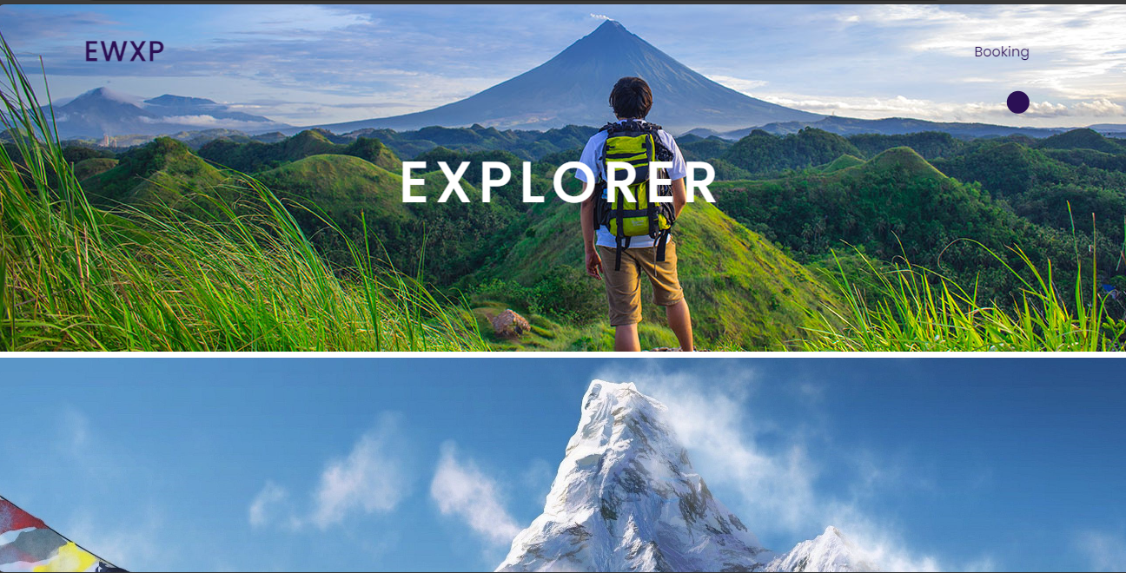



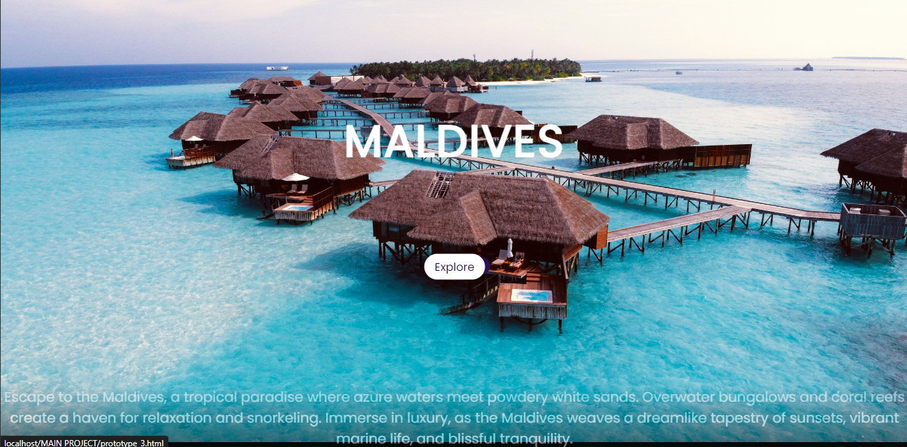

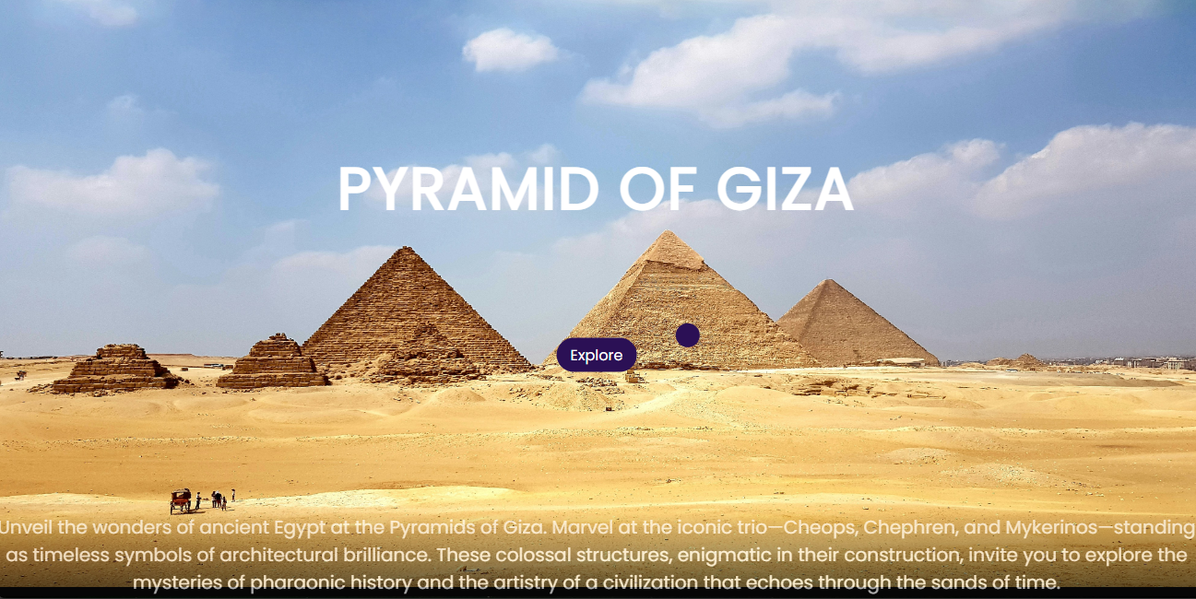



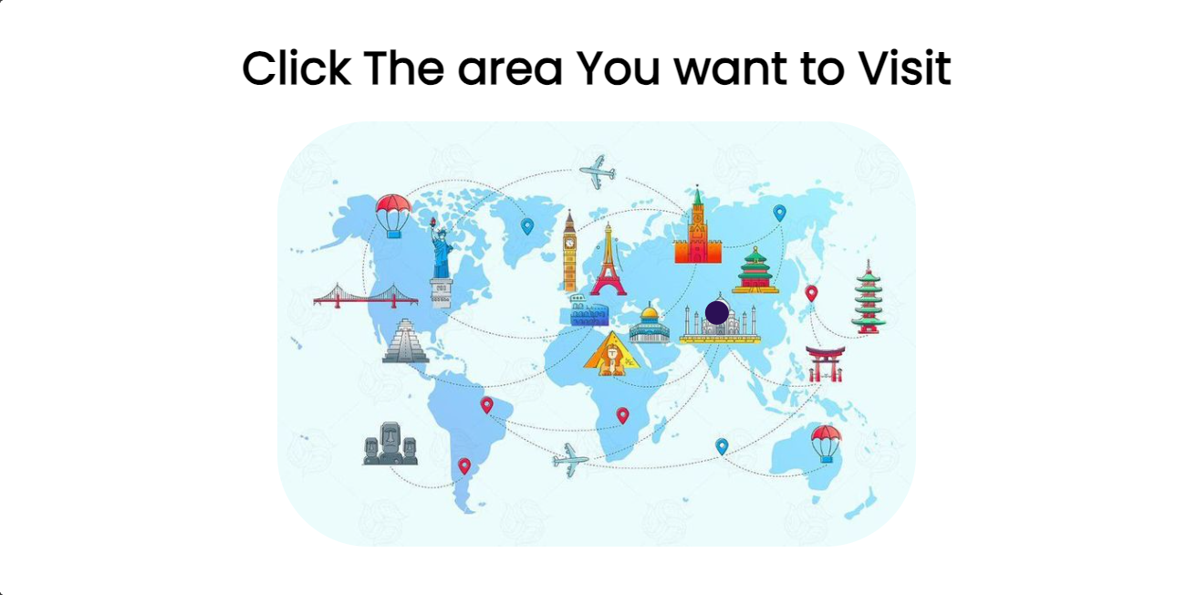



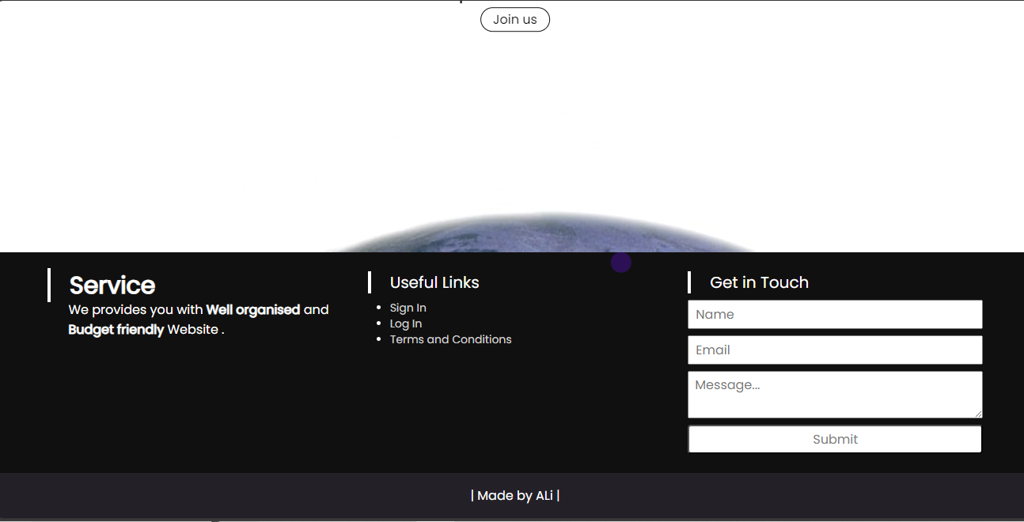

9.2 Tours Information :

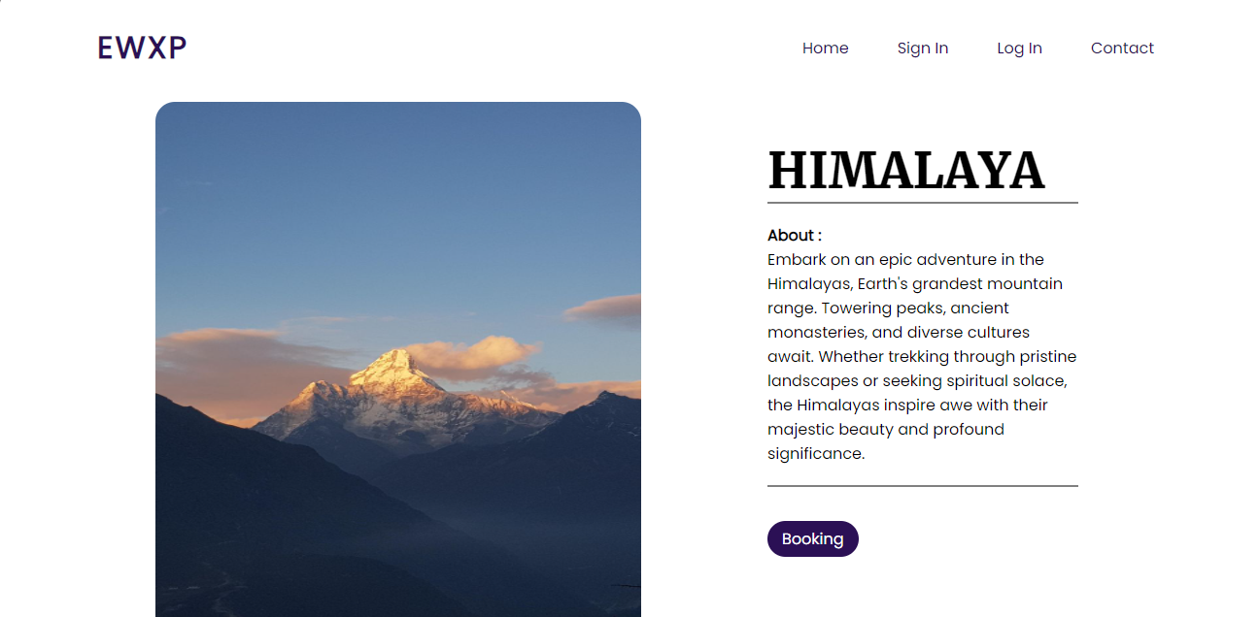

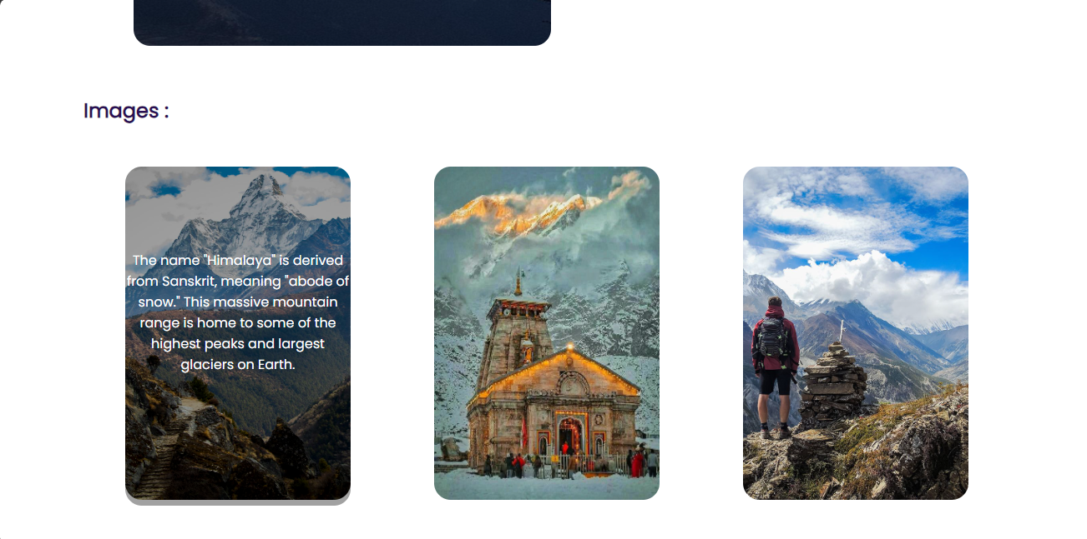

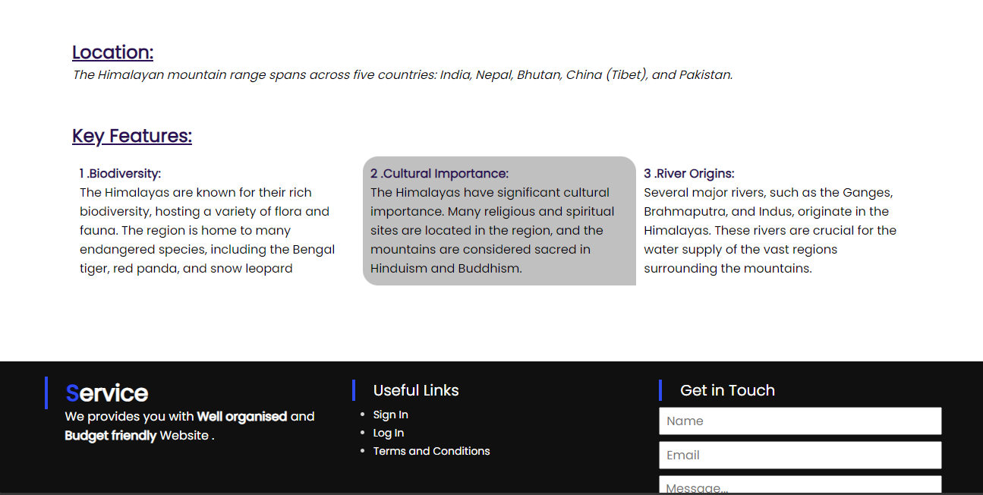

9.3 Booking :

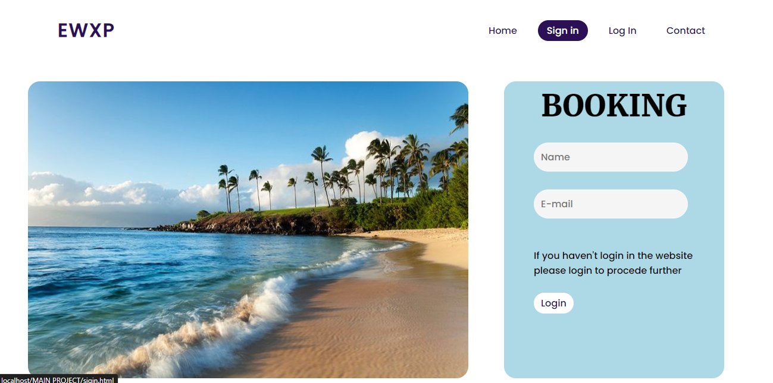

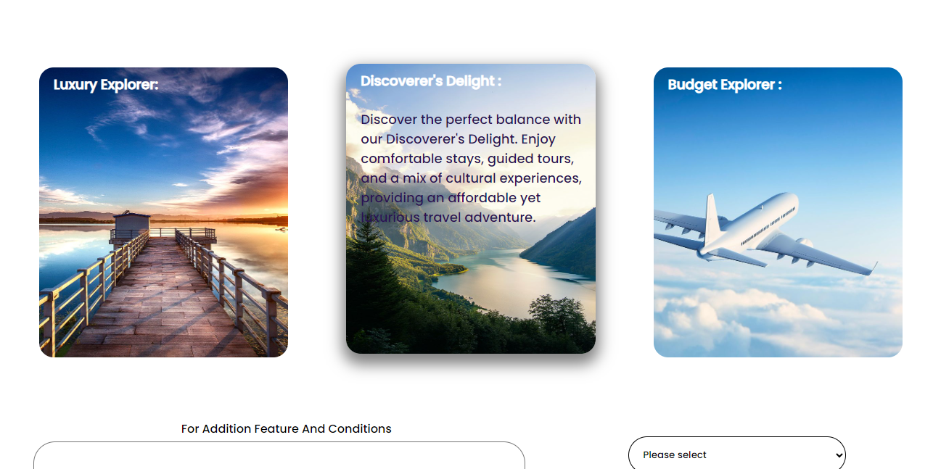

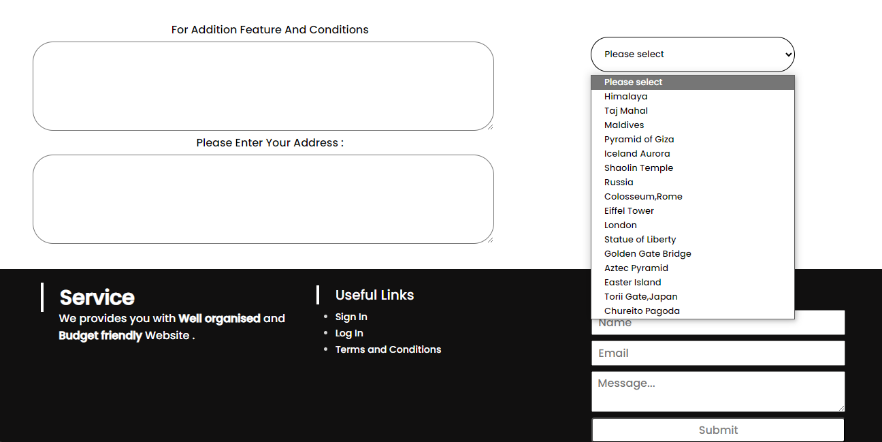

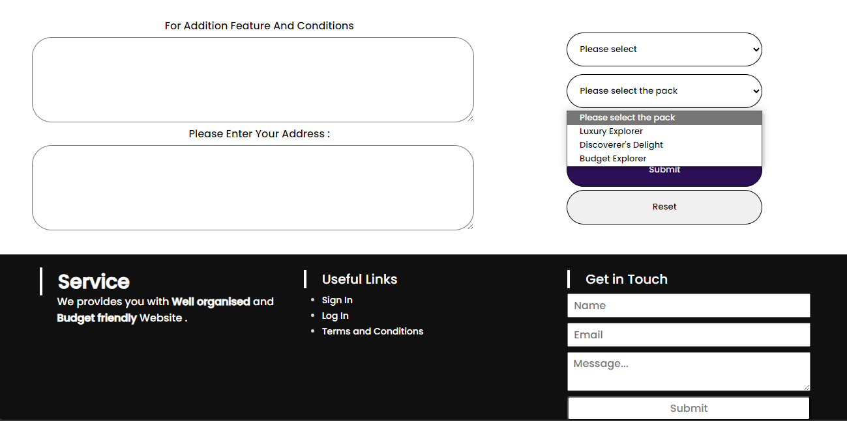

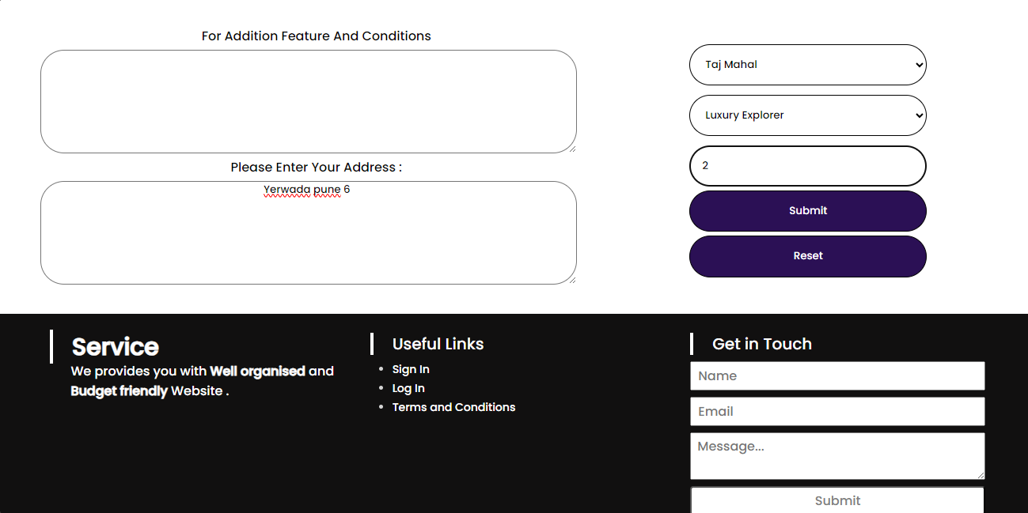

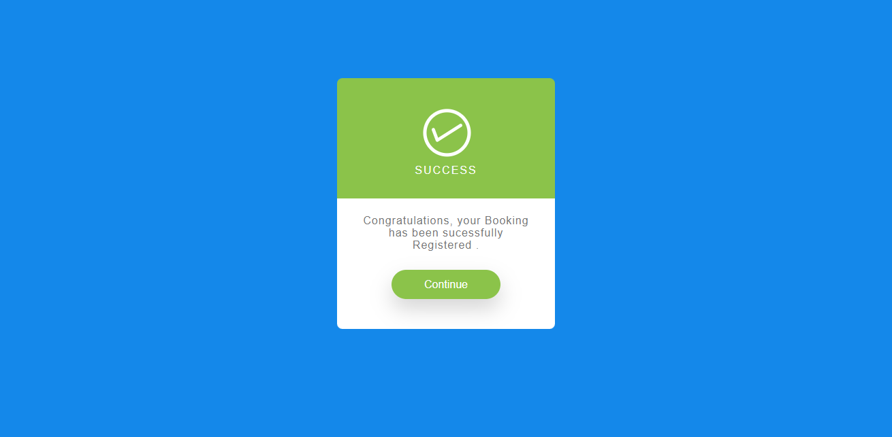

9.4 Log in , Sigin :

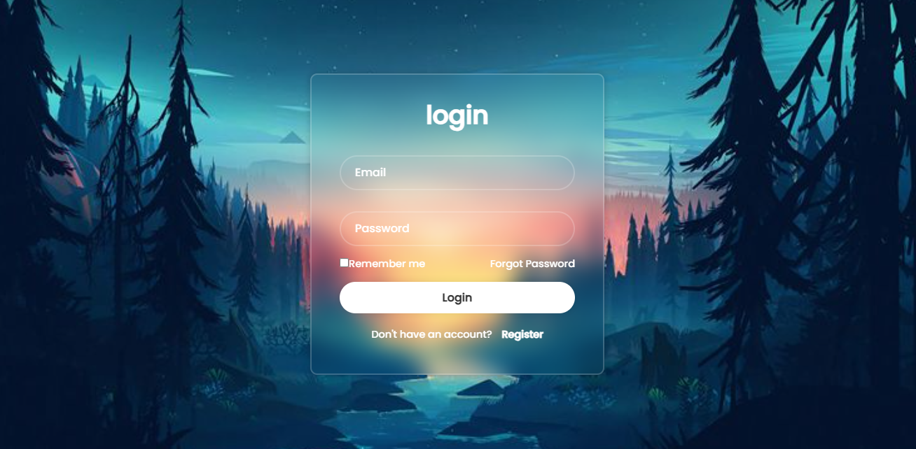

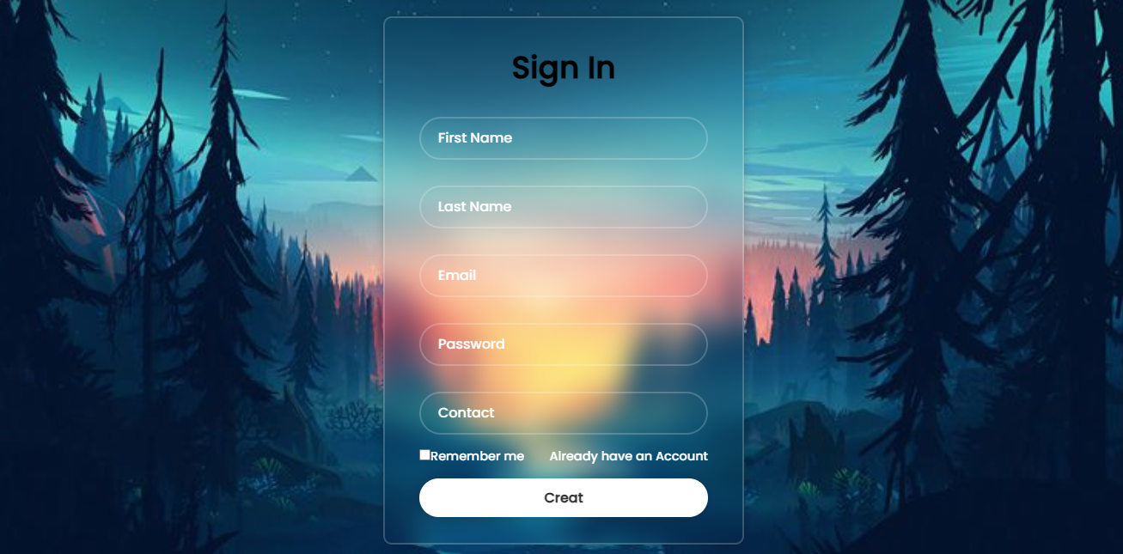

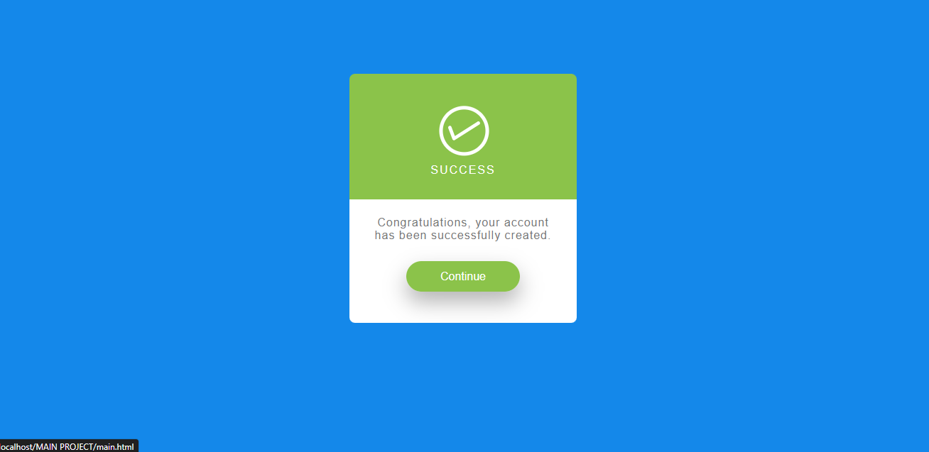

9.5 Admin View:

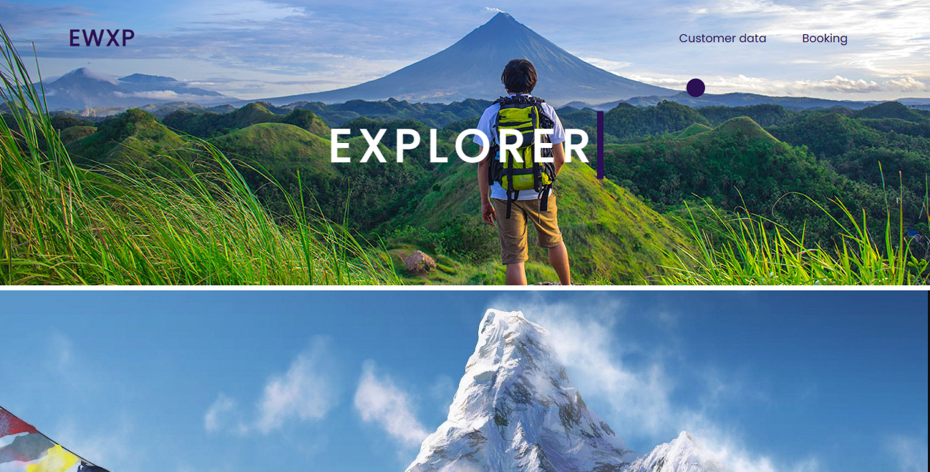

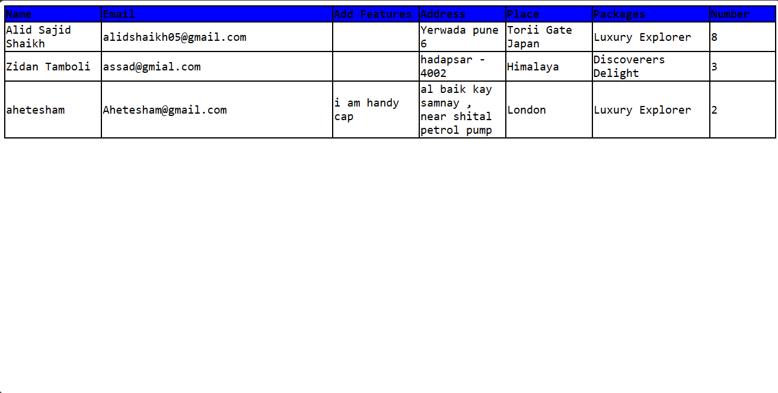

9.6 Backend :

9.6.1 Rgisteration :

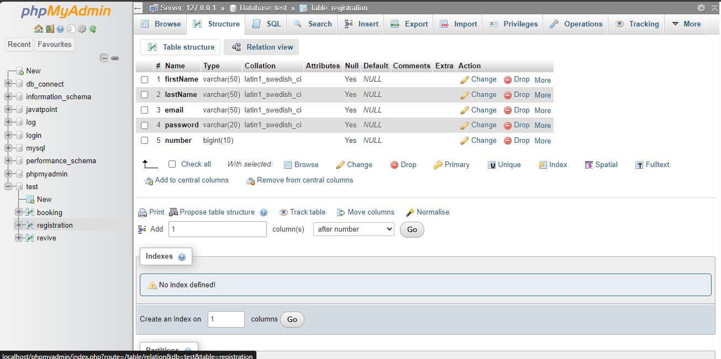

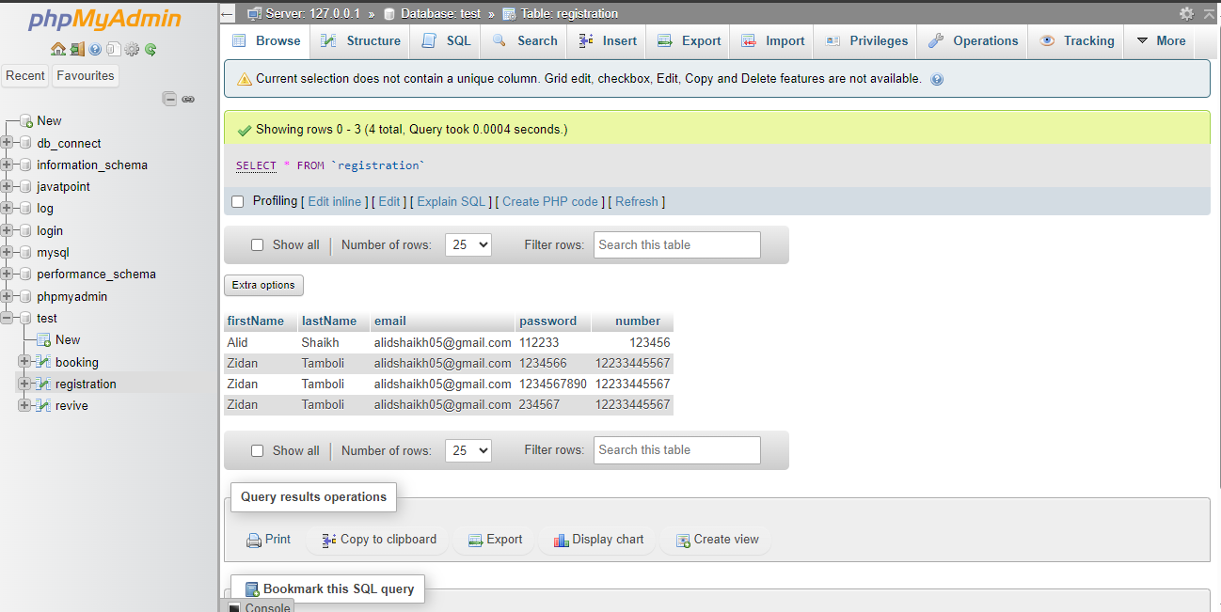

9.6.2 Booking :

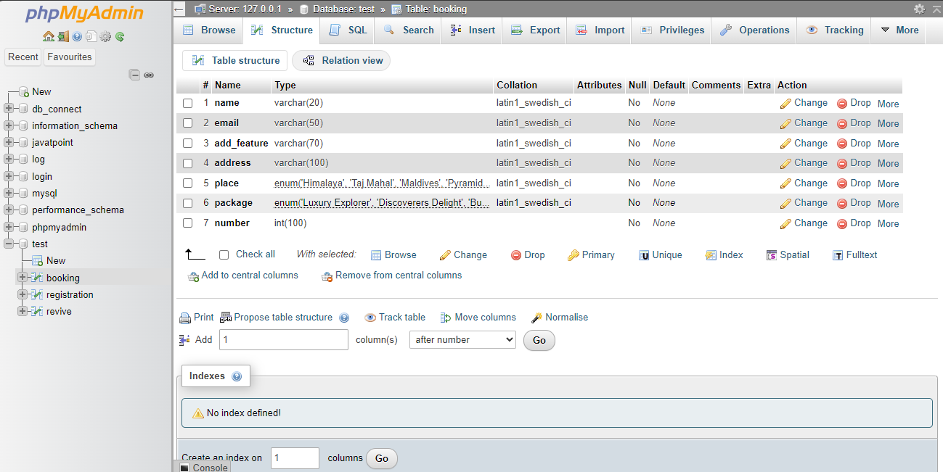

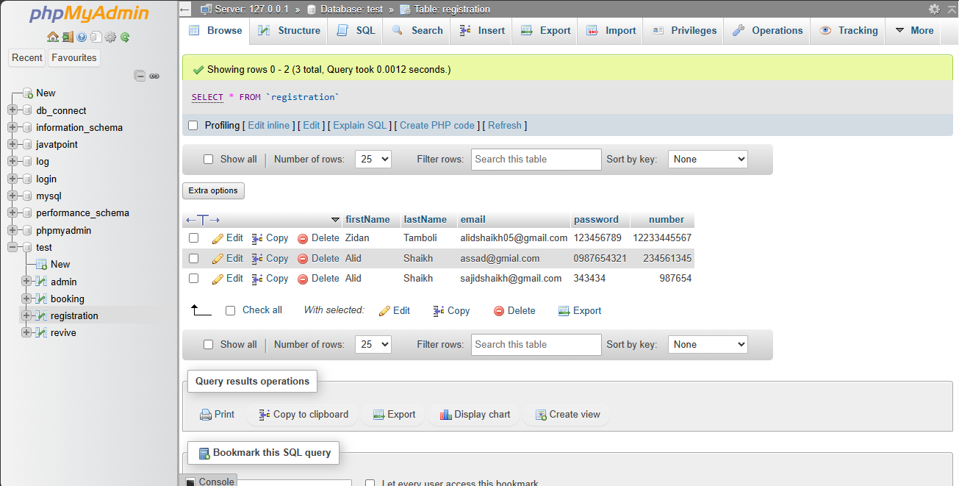

9.6.3 Admin Data:

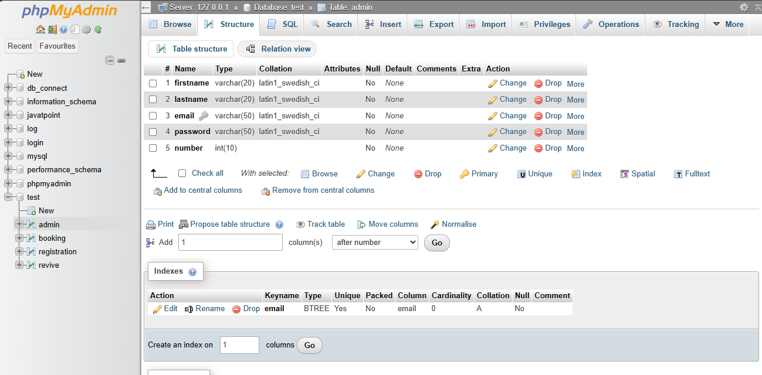

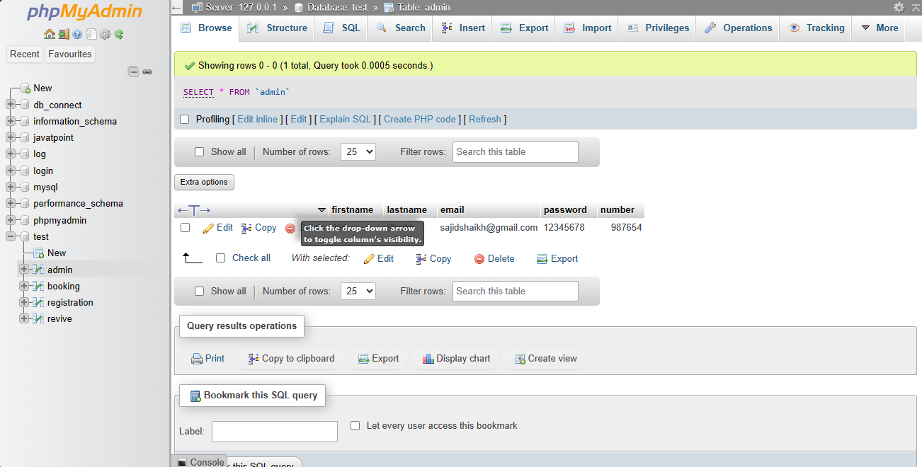

10. Conclusion:

The Tours and Traveling Website represents a significant milestone in the realm of online travel booking platforms, offering a seamless and user-friendly solution for travelers to explore, plan, and book their dream vacations. Throughout the development process, we have strived to create a website that not only meets but exceeds the expectations of our users and stakeholders, delivering exceptional value and experiences at every touchpoint.

10.1 Key Achivements :

1. Enhanced User Experience

2. Robust Functionality

3. Scalability and Flexibility

4. Value Proposition

Thank You